**SPRINT DELIVERY PLAN**

|  |  |  |  |  |  |  |
| --- | --- | --- | --- | --- | --- | --- |
| **SPRINT** | **TOTAL STORY POINTS** | **DURATION** | **SPRINT START DATE** | **SPRINT END DATE (PLANNED)** | **STORY**  **POINTS**  **COMPLETED**  **(AS ON**  **PLANNED DATE)** | **SPRINT RELEASE DATE (ACTUAL)** |
| Sprint - I | 11 | 6 Days | 25 Oct 2022 | 30 Oct 2022 | 11 | 30 Oct 2022 |
| Sprint - II | 9 | 6 Days | 01 Nov 2022 | 06 Nov 2022 | 9 | 06 Nov 2022 |
| Sprint - III | 10 | 6 Days | 08 Nov 2022 | 13 Nov 2022 | 10 | 13 Nov 2022 |
| Sprint - IV | 9 | 6 Days | 15 Nov 2022 | 20 Nov 2022 | 9 | 20 Nov 2022 |

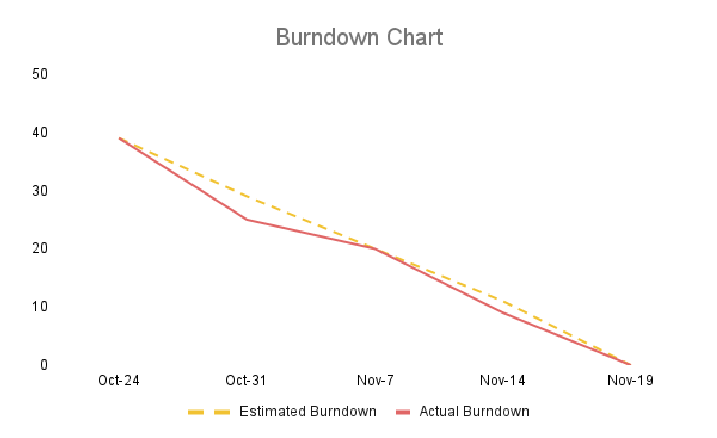**VELOCITY**

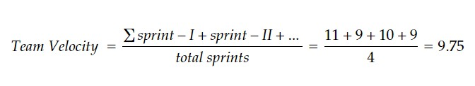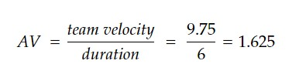

**BURNDOWN CHART**